

## Title: Comparison and Survey Report IT Server Room Visit Ibrahim Fibers

## SUBMITTED BY:

|  |  |
| --- | --- |
| Hamza Idrees | 20F-0132 |
| Abdullah Minhas | 20F-0204 |
| Muntazer Mehdi | 20F-0290 |

## SUBMITTED TO:

### Ms. Ayesha Liaquat

## SUBMISSION DATE:

## May 27, 2023

## DEPARTMENT OF SOFTWARE ENGINEERING, FAST-NU CFD

Comparison and Survey Report: IT Room at FAST NUCES and IT Server Room at Ibrahim Fibers

# Introduction:

This report provides a comprehensive comparison and survey of the IT room at FAST NUCES (National University of Computer and Emerging Sciences) and the IT server room at Ibrahim Fibers, a corporate firm. The purpose of this report is to evaluate and analyze various aspects of these two facilities, including their infrastructure, equipment, security measures, network interface and security, and overall effectiveness in supporting their respective organizations' IT needs.

# 1. Infrastructure:

## 1.1 FAST NUCES IT Room:

The IT room at FAST NUCES is located on the first floor of the Computer Science building. It spans an area of a small 250 square feet room. The room features air conditioning and temperature control systems to ensure the optimal operating environment for the IT equipment. The cable management is somewhat complex. The backup power supplies are placed within the it room.

## 1.2 Ibrahim Fibers IT Server Room:

The IT server room at Ibrahim Fibers is situated in the basement of the main office building. It occupies a larger space, covering around 500-750 square feet. The server room has raised flooring for cable management and utilizes a sophisticated cooling system to maintain ideal temperature and humidity levels. Their cable management was topnotch, and everything seemed to be carefully placed.

2. Equipment:

## 2.1 FAST NUCES IT Room:

FAST NUCES IT room is equipped with several high-performance servers, switches, firewall, storage arrays, and networking equipment. The room houses multiple racks to accommodate the various IT components efficiently. Additionally, it is furnished with backup power supplies, including UPS systems, to ensure uninterrupted operation during power outages.

## 2.2 Ibrahim Fibers IT Server Room:

The IT server room at Ibrahim Fibers boasts an extensive collection of servers, including both physical and virtual machines. It is equipped with enterprise-grade storage systems, redundant network switches, and robust firewalls. They have a backup storage system 37kms away from their main server room, in one of their factories, so incase of some natural disaster they may have an additional data backup.

# 3. Security Measures:

## 3.1 FAST NUCES IT Room:

FAST NUCES IT room has strict access control mechanisms in place. Only authorized personnel with valid identification cards are allowed entry. The room is monitored through surveillance cameras. Data security is maintained through firewalls, intrusion detection systems, and regular security audits.

## 3.2 Ibrahim Fibers IT Server Room:

Security is a top priority at Ibrahim Fibers' IT server room. Access is restricted to authorized individuals through a biometric authentication system and RFID card readers. The server room is monitored 24/7 with video surveillance cameras, and an advanced alarm system is installed to detect any unauthorized access or environmental anomalies.

# 4. Overall Effectiveness:

## 4.1 FAST NUCES IT Room:

The IT room at FAST NUCES provides a reliable infrastructure to support the university's IT requirements. It facilitates smooth network connectivity, server administration, and data storage for academic and research activities. The room is adequately maintained and allows for scalability to accommodate future technological advancements.

## 4.2 Ibrahim Fibers IT Server Room:

The IT server room at Ibrahim Fibers serves as the backbone of the organization's IT infrastructure. It supports critical business operations, including enterprise resource planning, customer relationship management, and data analytics. The server room is designed to ensure high availability, data redundancy, and disaster recovery capabilities. Their main centralized server room is connected to different cities spread over the country. These same servers provide data to someone as far as on port qasim, Karachi to someone as near as their office in Faisalabad.

# 5. Network Interface and Security:

## 5.1. FAST NUCES Network Interface and Security:

### 5.1.1. ISP and Topology:

* FAST have multiple ISPs which are PTCL, HEC and Ministry of IT
* FAST uses a combination of tree and start topology.

### 5.1.2. Hardware Equipment:

* The network devices are from different companies like routers, switches and modems belongs to CISCO and PCs and other hardware belongs to HP, Dell, and others.
* Routers are mainly of the cisco 2900 series.
* It uses dual link configuration of network which ensures network redundancy and reduces the risk of network shutdown in the event of a fiber link failure.
* Layer 3 switches are preferred to utilize in the network infrastructure to provide advanced routing functionalities and enhance network performance.
* Power Backup of unto 3 mins on UPS (online) if the main grid fails, then after 3 mins it’ll be shifted to second UPS which will have backup of 1-2 hours.

### 5.1.3. Network Equipment:

* Distribution boxes are deployed throughout the campus to efficiently distribute the network to various labs and departments, ensuring seamless connectivity.
* The network switch model used in the university is Cisco 3560.
* The university utilizes an NVR system with support for 256 cameras and 2 video recorders for video surveillance purposes.

### 5.1.4. Network Security:

* A firewall manages proxy services and safeguards the network against unauthorized access and external threats.
* Fortinet Firewall is used.
* Network monitoring software is used to monitor the network continuously.
* A log is maintained against each device connected to any of the network in the system.

### 5.1.5. Network Standards and Protocols:

* DHCP (Dynamic Host Configuration Protocol) is used to automatically assign IP addresses to students, simplifying the network configuration process.
* Static routing is implemented to ensure efficient routing within the university network, catering specifically to the requirements of faculty members and other users.
* RIP and OSPF protocols are implemented for efficient data transmission and controlling delays.
* More than 5000 privates Ips are available.
* 256 cameras capacity maintained under private Ips.

## 5.2. Ibrahim Fibers Network Interface and Security:

### 5.2.1. ISP and Topology:

* Mobilink is their single ISP.
* It has dual fiber configuration to their office, so that in case of any disaster they have the second link working as well.
* They use MESH topology. The reason they provide against the argument of maintainability and cost factor is reliability, which is a very big factor for them.

### 5.2.2. Hardware Equipment:

* They prefer to work in CISCO eco system. So, they mainly have an ecosystem built around equipment from cisco.
* Layer 3 switches are used instead of routers as they are more reliable and provide higher speed.
* Have 2 power grid supplies from FESCO, the second one in case of the failure of first one. Then have 2 other power sources just in case of power failure from both of grid sources.
* In case of failure of all the sources, they have a back of 1hour on UPS, that will keep the system and whole office alive for 1 hour without interruption.

### 5.2.3. Network Equipment:

* They use cisco 9200 series switches, Fiber interconnection of 6400 series, and 5520 series firewalls mainly. Their security is further divided into layers which we will talk about later in this document.
* Software for monitoring and controlling bandwidth in the network.

### 5.2.4. Network Security:

* They provide static IPs to the devices in their office so it will be better for the purpose of monitoring. Furthermore, they can track the users and bandwidth consumption of users outside Static Ips as well.
* On the very outer layer they have cisco 5520 firewall for whole monitoring purposes. After that they use SOPHOTOS software that can block or firewall websites. After that they have Barracuda software that can scrap through emails, and after that they have a layer of Kaspersky software installed at every system of theirs to ensure security.

### 5.2.5. Network Standards and Protocols:

* Static Ips are assigned to devices connected to the office. Dynamic to those of public Ips that are outside of the office.
* Static NAT is applied on the overall network.
* BGP and EIGRP protocols are implemented for the smooth transition of data.
* More than 10000 available Ips from Classes B, C, and D
* Capacity of more than 5000 camera. As they have area of 1sq KM

# Conclusion:

In conclusion, both the IT room at FAST NUCES and the IT server room at Ibrahim Fibers demonstrate a strong commitment to maintaining robust IT infrastructure. While FAST NUCES focuses on providing reliable IT support for academic and research activities, Ibrahim Fibers' server room is geared towards supporting critical business operations. Both facilities exhibit sound infrastructure, advanced equipment, and comprehensive security measures to safeguard their respective organizations' data and systems.

Application Screenshots:

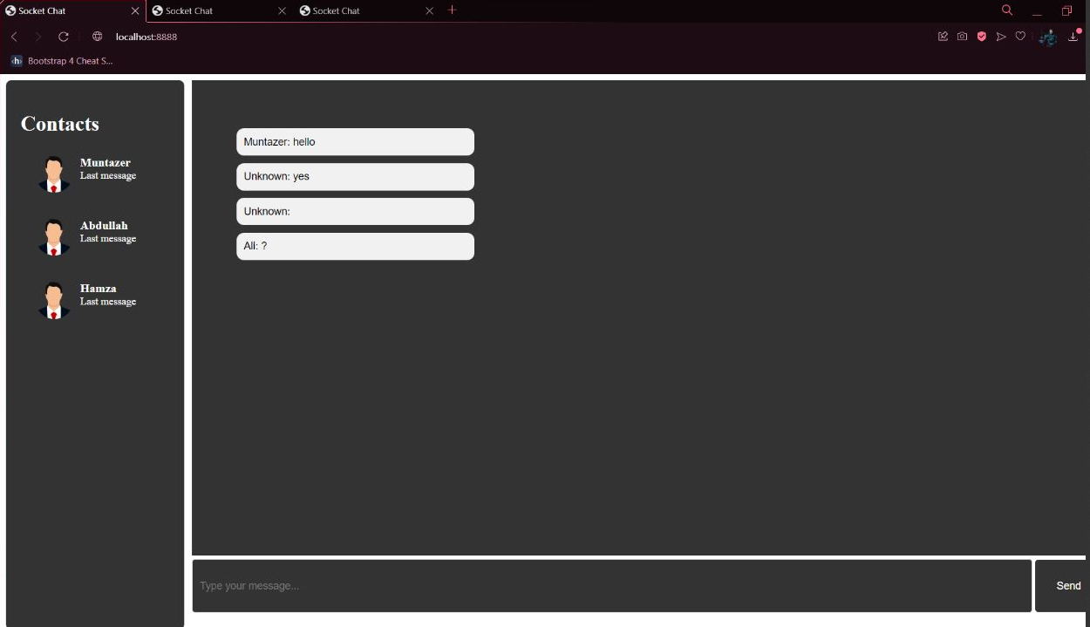

Presentation Link:

https://drive.google.com/drive/folders/1h68FvLFWWKeGXQfLhJ6IS8uUCurBo7uE?usp=sharing